SQL SERVER INTEGRATION SERVICES (integration of services)

Services ssis can perform:
- ETL services
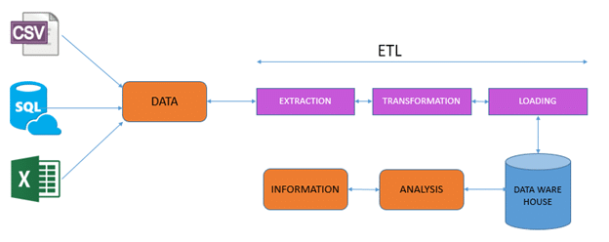

- Windows Admin services
->watching events
->Reading logs
->unzip folders
->collect status
3) SQL server Admin services
->Taking back Backups
-> Transfer DB/Jobs/sp’s etc.

Solution:
Solution consists of projects and solution file saved with .sln
Project:
Project consists of packages and saved with .dtproj
Packages:
Packages consists of tasks, transformation, container, parameters and connection managers etc and saved with .dtsx.
->Parameters saved with .Params
->Connection managers saved with .conmgr

Basic components of ssis:
1.controlflow:
Control flow consists of consists of Tasks and Containers and it is controlled with the help of precedent constraints.
2.Data flow:
Data flow consists of sources, destinations and transformations. Help you to modify the data according to the business requirement.
3.Event handlers:
Event handler tab enable you to create the workflows (i.e just like ssis packages),that handle the different events that are raised in the execution of a package.
Those events are like
1.On error 2. On pre execution 3.on pre validation 4.on post execution 5. Post validation.
6.on post validation 7.on variable change 8.on query change 9.on progress etc.
4.Package explorer:
It is know thing but single view of a package, here we can see what all the things used in the package like tasks, transformations, containers, variables, parameters etc.
5.Parameters:
Parameters help you to provide the user interaction, Basical it holds the value and makes the package dynamic.
Basically, we have two kind of parameters those are 1. Package level parameters 2. project level parameters.
Variables in ssis:
Variables also holds the values, but variable doesn’t provide the user interaction, makes the package dynamic with the help of configurations,
Basically, there are two types of variables 1. system level variable 2. User defined variables.
->System level variables available in the package level, container level, task level and also event handlers level as well.
->user defined variables available in which based on the scope you declare.
Annotations:
Annotations Describe the package, that help you to understand the package more better manner.
These nothing, but comments in programming language.
Naming conventions:
For the better understanding of the packages you can also give the better naming convention for the tasks, transformation, containers etc.
@[User::Archive_folderpath]+Replace( @[User::file_name],".txt","")+"_"+Replace(substring((DT_WSTR,30) GETDATE(),1,16),":","_")+".txt"

